**Daily Scrum or Standup Meeting**

Team name: 5th Element

Scrum Master: Leonardo Craven

Date: October 28, 2021

| **Team Member** | **What did you do since the last scrum?** | **What do you plan to do before the next scrum?** | **What obstacles do you have?** |
| --- | --- | --- | --- |
| Leo | Updated documentation with all changes | Update archived tournament page to show only tournaments player signed up for if player, all tournaments if manager  Plan for scores/leaderboards | None |
| Gavin | Finished adding CSS to previously worked pages, added capability for managers to delete existing tournaments | Plan for scores/leaderboards | None |
| Andrew | Worked on sponsor existing tournaments page | Finish sponsor existing tournaments page | Nothing |
| Brock | Finished adding CSS to previously worked pages, started working on registered tournaments page | Work on registered tournaments page | Midterms (until Monday) |

# Burndown

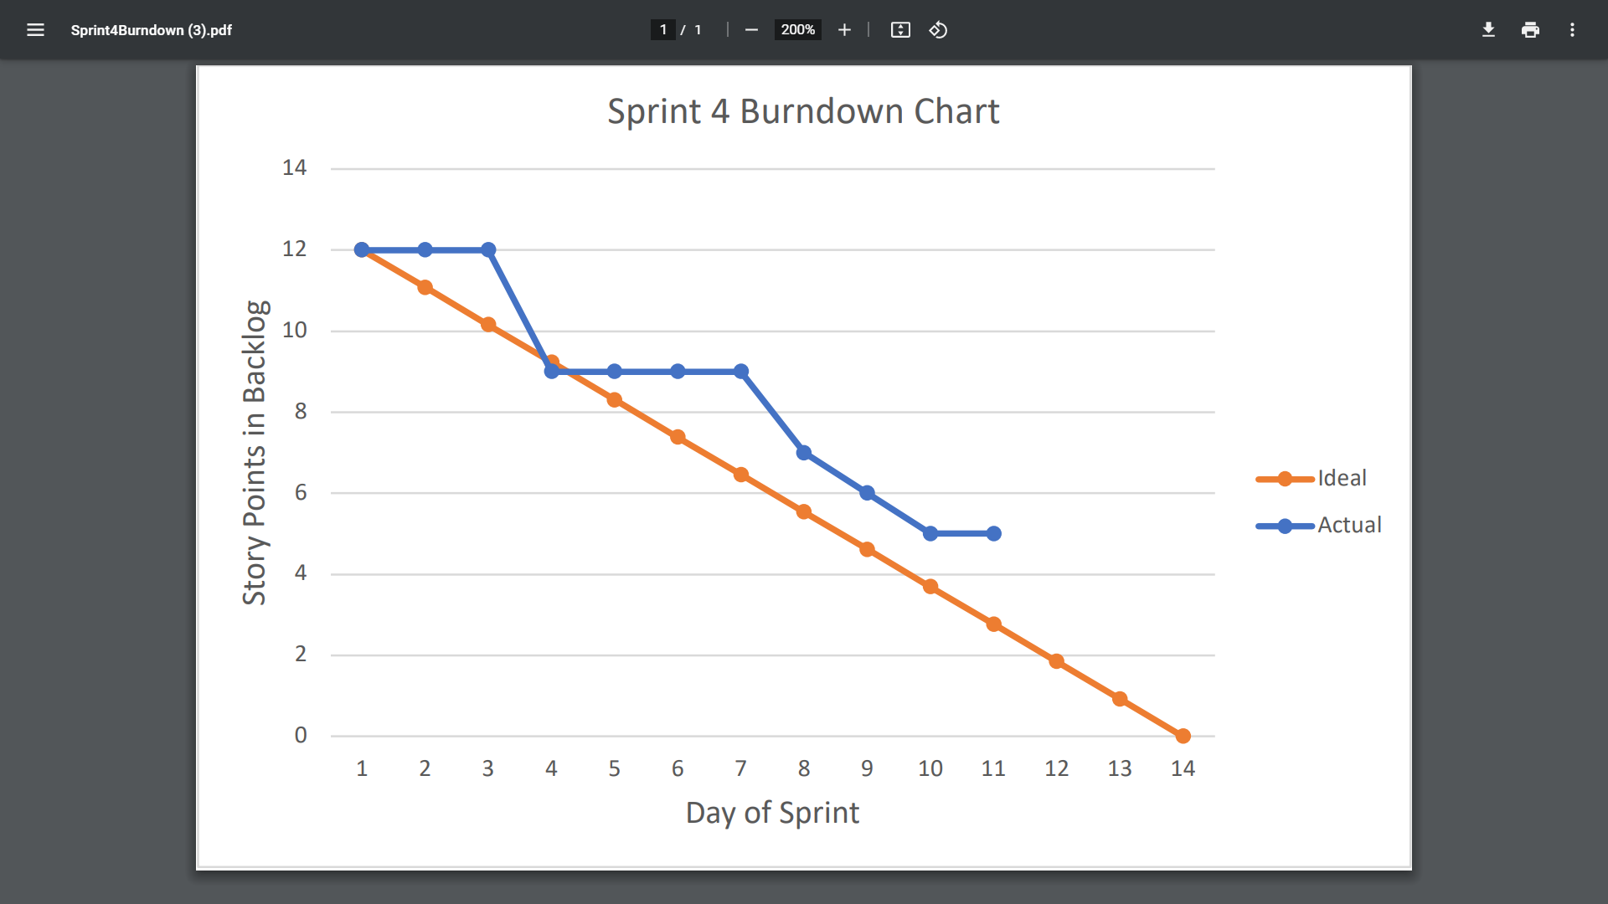

# Screenshot of you project board

